Portfolio

Christopher Wrigley

Table of Contents

About Me…………………………………. 3

Resume…………………………………… 4 – 5

Internship………………………………… 6 – 7

Cover Letter…………………………… 8

Social Media Presence…………………………… 9

Projects……………………………………… 10 - 11

2

2

About Me z

My name is Christopher Wrigley and I have wanted to get into the gaming industry for a while now. My interest for creating games started in 2015 when my parents took me to a careers expo. While I have only wanted to make games for a short while, my love for games has been with me for my whole life. It all began when I was very young and my parents got me a Nintendo 64, I played that constantly, playing games like ‘Super Mario 64’ and ‘Donkey Kong 64’. Around the same time, I also had a PC and played games like ‘Soldier of Fortune’. As I grew up, I got a PlayStation 2 which I enjoyed for many years to come, playing games such as ‘Ratchet & Clank’ and ‘Jak & Daxter’. In 2008 I got an Xbox 360. I started playing games like ‘Halo’ and ‘Call of Duty’. At the end of 2009 I was introduced to the wonders of Xbox Live and the online community which until then my only multiplayer experience was split-screen Halo with my friends. This opened my eyes as to what gaming could show us and how it can bring people from all around the world to play video games. For years after that I played constantly throughout my school years, playing with friends, playing with random people and everyone in between. In later end of 2013 the Xbox One was released and I switched from the Xbox 360 to that. Up to the present day I still have the Xbox but I have also expended my capabilities by a PlayStation 4 and a Gaming PC. I hope that with all my experience with gaming I can bring a useful hand to the Gaming Industry and contribute to its growing size and ambition. In the Industry I will be a very well working person with the capacity to complete my work with the upmost time and effort. I am ready to do whatever is required of me and will do my best to uphold the workload to the best of my abilities. My skills that will contribute to the gaming industry include Knowledge in the unity game engine, able to the C# coding language and the C++ coding language with SFML. I have created several games from my time at college, both as solo projects and as group projects with members from other gaming divisions and members from different professions entirely such as animation. this has taught me how to work with other people efficiently to deliver a quality product to the client and to ensure that the consumers of the product receive an enjoyable experience. I have made many friends in this environment and I hope to keep in contact with them in order to serve as a gateway into new opportunities for both them and myself. I wish to contribute my skills to the gaming industry so that I can influence a new generation of gamers to pursue their dreams and to strive for the future.

|  |
| --- |
| Resume  Christopher Wrigley  Phone: 0401 116 011 • E-mail: c_wrigley@hotmail.com |

|  |  |
| --- | --- |
| Objective | |
| My Main Objective for my life currently is to successfully finish all my courses, learning to be a video game programmer.  Education | |
|  | 2016 – Present SAE Quantm Bachelor of Game  Development specializing in programming  2010 - 2015 High School Certificate (ST Clair High  School)  2014 – *Present* Australia light craft pilot license  2013 – 2013 High Distinction (The Great Australian Science  Byte)  The University of Sydney |
| Professional experience   * Three year’ work experience as a Crew and Team Member * Fun and friendly nature; value customers and takes complete pleasure in every kind of work * Professional demeanor and neat appearance   Excellent oral communication skills Christopher Wrigley  **2014 - *Present* (KFC Australia Pty Ltd) Cook-*Casual***  **Job Summary:**  Duties include, food prep, cooking chicken, stocking bins, washing dishes, cleaning all parts of the restaurant and kitchen, responsible for set up and shutdown of kitchen, training new employees on procedures of how to cook as well as sanitation procedures and policies, cleaning up the outside of the restaurant, putting away stock that comes in on the delivery truck.  **2013 – *Present* Crystal Clear Loan Processing (family run business)-*Casual***  **Job Summary:**  Duties include help with printing, scanning / copying, faxing and emailing any documents that need to  be sent to different Financial Companies.  ****2012 – 2013 Lawn Mowing****  **Job Summary:**  4  Provide lawn mowing service including cleaning gutters and yard care.  **RELEVANT SKILLS w**   * Knowledge of C# and C++ programming languages * Knowledge of the unity game engine * Highly skilled in working in the kitchen * Team Player / Customer Service * In-depth knowledge of basic kitchen duties and food preparation * Ability to multitask and prioritize responsibilities * Computer – MS Office Suite, POS, Scanning, Photocopying, Faxing, Printing   and generic sales and business software  ACHIEVEMENTS q  VOLUNTEER EXPERIENCE   * Anzac Day Parade (Sydney) * Red Shield Appeal * Clean up Australia Day   INTERESTS / ACTIVITES     * Member of St Clair High School Backstage Hands   Referees | |

**Internship**

**Link:** [**https://blizzard.taleo.net/careersection/2/jobdetail.ftl?job=16000V7&src=JB-1052**](https://blizzard.taleo.net/careersection/2/jobdetail.ftl?job=16000V7&src=JB-1052)

**Software Engineer Intern, Hearthstone**

**Team**

**:** Internship

Greetings, students! We’re geared up here to offer another round of epic internship experiences in summer 2017. The internship program offers the opportunity to pa use your studies for one summer and work side-by-side with Blizzard Entertainment employees in your area of interest, doing real work that oftentimes ends up in production. As such, we hold you to the same high standards as anybody else in the company.

Just like our gameplay experiences, Blizzard internships are a fully immersive experience. We want interns who are enthusiastic about what they want to do for a living and excited to come in every day to learn and contribute in this hyper-creative atmosphere. Being fully engaged with our team also means communicating effectively and maintaining an open mind - one that is receptive to feedback and able to adapt and grow. Your hobbies and interests can also play in your favour. Passion for technology, gaming, game development, and an in-depth knowledge of Blizzard games, products, and services will always be a plus with us, regardless of the position you’re applying for. Be passionate about who you are, be into our industry, and be willing to go all-in and embrace this opportunity to the fullest!

**Quest Objectives**

Join the Hearthstone team as a software engineering intern for Summer 2017! The team is looking for passionate and skilled student engineers with a willingness to learn and grow. Interns should expect to work closely with designers and artists to recognize the shared vision and see it through from concept to completion. The ideal student has a long standing passion for playing games, a strong aptitude for critical thinking and analysis, outstanding people skills, and demonstrated game programming experience (in the personal, educational, or professional arena).

Intern tasks could be focused in any of the following programming concentrations:

* Gameplay (AI, interaction, etc.)
* Tools (powerful toolsets for code, art, design, audio, or localization pipelines)
* User interface (effective and elegant user interfaces and scripting)
* Server (memory and data management, multi-threading, networking, databases, Linux builds, core systems, etc.)

**Intern Guild Requirements**

* Currently enrolled in a college or university
* Returning for at least one more semester or quarter following the Summer 2017 internship
* Able to work fulltime hours for 11 – 12 weeks at the Blizzard office indicated in this job posting between May 22, 2017 – August 11, 2017 or June 12, 2017 – September 1, 2017 (group dates depend on when you get out of school)
* Authorized to work in the US

**Level Requirements**

* Passion for technology, gaming, and game development
* Passion for and in-depth knowledge of Blizzard games, products, and services
* Demonstrated game programming experience (personal or professional)
* Experience developing and debugging in C / C++ or C#
* Experience programming in at least one scripting language (Lua, Python, Perl, etc.)
* Strong mathematics background (logic, linear algebra, geometry, statistics and probability, etc.)
* Understanding of data structures and algorithms
* Interest and familiarity with at least one of the potential programming concentrations listed above

**Recommended Talents**

* Majoring in a related field (computer science, computer engineering, real time interactive simulation, etc.)
* Game design aptitude or previous experience working on game development projects in a game design role
* Linux, FreeBSD, or Solaris development experience, and networking experience in TCP / IP and UDP protocols

**Quest Items**

* Resume
* Cover letter
* Use cover letter to indicate which specific game programming concentrations interest you most

Cover Letter z

Dear Hiring Manager

I have looked at your Internship and I believe that I am the best person to take it on. I have many of the requirements that you have requested and I am certain that I will prove to be a valuable resource to your team. I am currently enrolled in college and I am able to have the time to participate in the internship, and I am able to work to your times and can get a VISA to work in the US. I have a passion for the gaming industry and would like to contribute to it in any way I can. I am quite proficient in Blizzard products such as Wow, Overwatch and StarCraft just to name a few. I am able to demonstrate what projects I have done at college to you. I have experience with C++ and C# for debugging and programming. I am very adept in mathematics coming second in my high school advanced maths class. I am able to understand and interoperate data structures and algorithms. For these reasons I hope that you consider me for the internship as I will be a very welcome addition to your team.

Yours Faithfully

8

Social Media Presence z

My social media presence currently only consists of my Facebook account and Instagram account. I made my Facebook account in 2009 when I was 12 years old and my Instagram account in 2016 when I was 18. My current use of these accounts is to interact with my friends and family my sending messages and writing on their feeds or vice-versa. The purpose of getting a professional presence online is to provide a way for potential employers to see me in a professional light and to have a public face for people to see what I am all about. In order to progress with my career into the Gaming Industry, I will need to improve my social media presence to a more professional level that will reflect my ability to perform well within the industry. A way to improve my social media presence is to open my possibilities to more social sites such as LinkedIn or twitter for example to broaden my presence online and increase my view. It is important for me, as a video game programmer to have a professional social media presence so that I am more accessible to future employers so they can know about me, what I do and what I have done.

Projects z

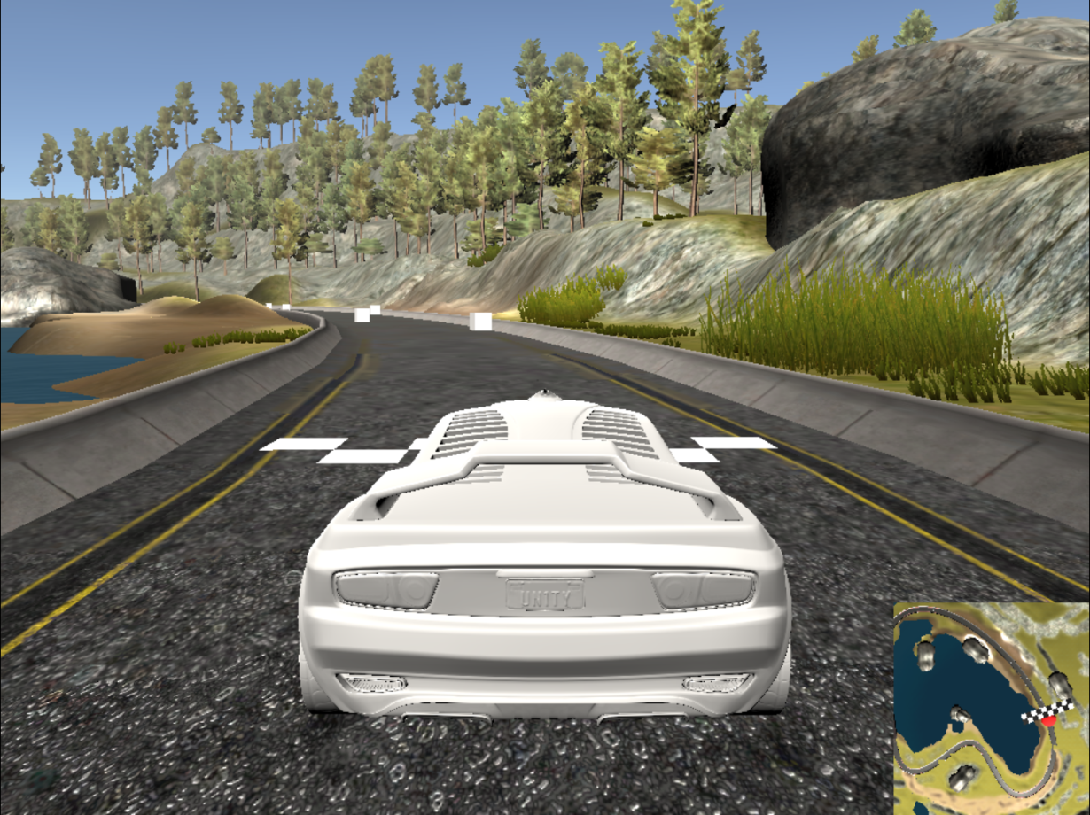The Random Racing Game

The Random Shooting Game

No Image Yet

Tanky McTankface

No Image Yet